# Release Information

|  |  |
| --- | --- |
| Release | 4 |
| Leader | John W Hunter |
| SVN Revision Number | 23165 |

Release 4/Deployment consisted of work on polishing code, making sure that code meets coding standards, updating documentation, updating tests, and cleaning directories.

# Progress Summary

|  |  |  |  |
| --- | --- | --- | --- |
| **Stories and spike solutions planned for this release** | | | |
| **Story, Spike** | **Description** | **% Impl.** | **Notes, plan for completion** |
| S.UI.4 | Administrative Access | 50% | Implement Story |
| S.SO.3 | Multistage Flights | 100% | Method Decomposition |

|  |  |  |
| --- | --- | --- |
| **Accomplishments by engineer** | | |
| **Team Member** | **Total Time (hrs)** | **Stories, Spikes implemented** |
| John Hunter | 10.75 | Refactoring for coding standards check, updating documents, investigating test coverage issues |
| Peter Emery | 8.65 | Refactoring flight controller, working on test coverage, investigating test coverage issues, fixing file include errors |
| Scott Schroeder | 12.5 | Refactoring GUI, updating documents, working on test coverage issues, fixing errors found in GUI |
| Nathan Blaubach | 8.1 | Refactoring flight controller, working on test coverage, investigating test coverage issues, fixing file include errors |
| **Total Hours** | **40** |  |

|  |  |
| --- | --- |
| **Document updates** | |
| **Document** | **Changes** |
| Group-4-status | Updating status weekly |
| Group4StoryBook | Updating storybook to reflect work done on stories |
| Group4ClassDiagram | Updating class diagram to reflect changes to classes while refactoring |

# Plan for Next Release

No plans for future releases, system is being deployed.

|  |  |  |  |
| --- | --- | --- | --- |
| **Stories and spike solutions planned for upcoming release** | | | |
| **Story, Spike** | **Description** | **Est. Hours** | **Notes, plan for completion** |
| **Total** | | **0** |  |

|  |  |  |
| --- | --- | --- |
| **Assignments** | | |
| **Team Member** | **Stories, Spikes implemented** | **Tot. Hrs.** |
| **Total** | | **0** |

# Issues

|  |  |  |  |  |
| --- | --- | --- | --- | --- |
| **Issue Number** | **Discovery**  **Date** | **Resolution**  **Date (Est.–Act.)** | **Responsible Person** | **Description (Problem / Resolution)** |
| R4.1 | 4/21/2015 | 4/21/2015 | John Hunter | Admin access was deemed non-essential for system deployment, further work was suspended on story. |
| R4.2 | 5/3/2015 | 5/5/2015 | John Hunter | Multiple issues arose when trying to compile the system on a non-Windows platform. Issues included problems with included standard library classes and the c++ version of the gcc compiler on the io.uwplatt.edu server, both resulted in the inability to compile the most basic of classes for the system to run.  Further work on computing statement test coverage suspended, test coverage calculated using method coverage alone. |

# Test Coverage

Test coverage only uses method coverage based on method calls in test units, statement coverage unavailable (See Issue R4.2)

|  |  |  |  |
| --- | --- | --- | --- |
| **Class** | **Public Method Count** | **Methods Tested** | **Notes** |
| ReservationCommander | 5 | 5 |  |
| Command | 2 | 0 | Abstract class |
| AddToCartCommand | 2 | 2 |  |
| RemoveFromCartCommand | 2 | 2 |  |
| CancelReservationCommand | 2 | 2 |  |
| ReservationController | 20 | 20 |  |
| FlightController | 1 | 1 |  |
| HotelController | 1 | 1 |  |
| Flight | 13 | 13 |  |
| Seat | 8 | 8 |  |
| Hotel | 8 | 8 |  |
| Room | 7 | 7 |  |
| Reservation | 29 | 28 | setReservationTime is untestable |
| RoomReservation | 10 | 10 |  |
| SeatReservation | 11 | 11 |  |
| FlightStage | 7 | 7 |  |
| **Total** | **128** | **125** | **Test Coverage** |
| **97.66%** |

# Screen Shots

Search Flights/Hotels Screen

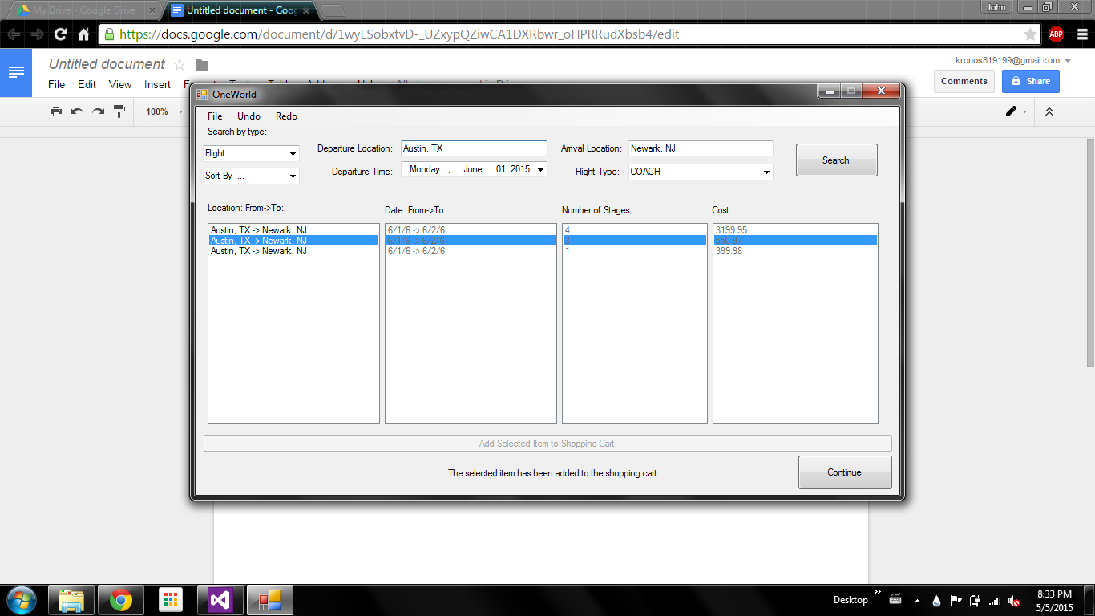

Review Reservations Screen

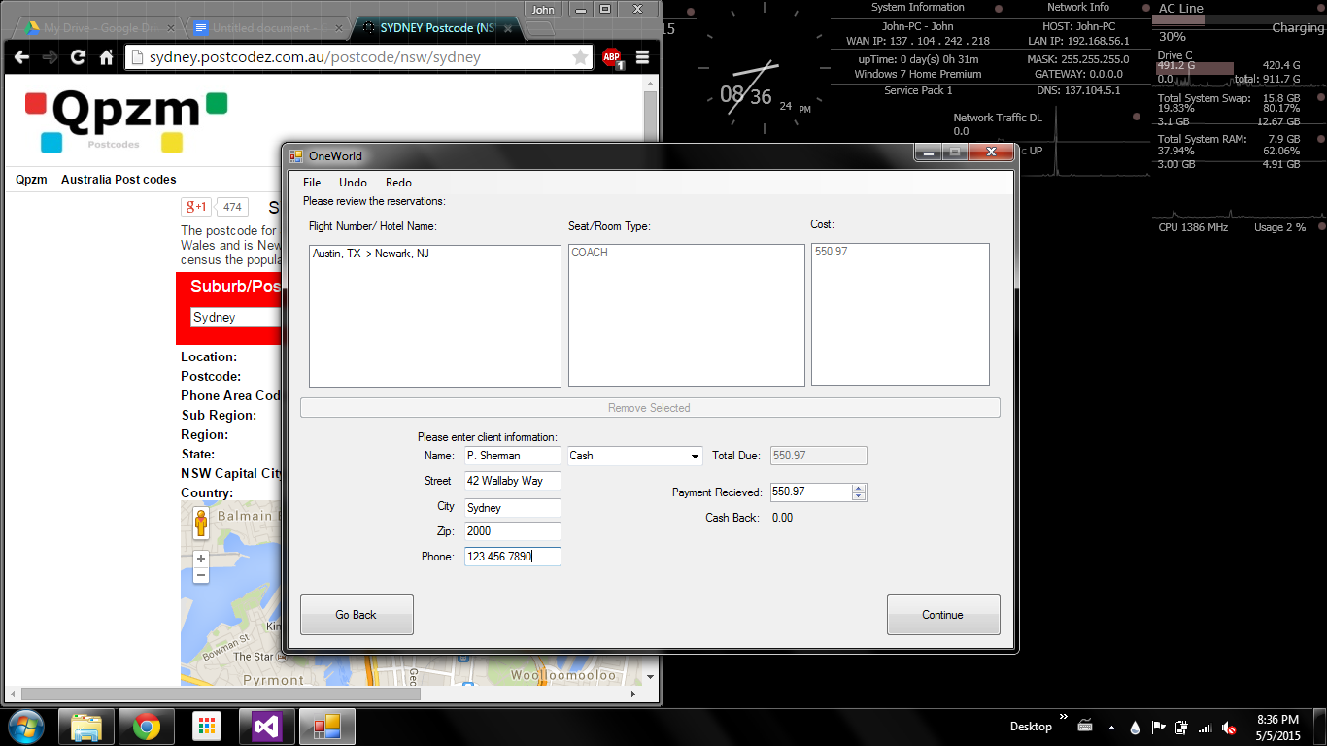

Confirmation Screen

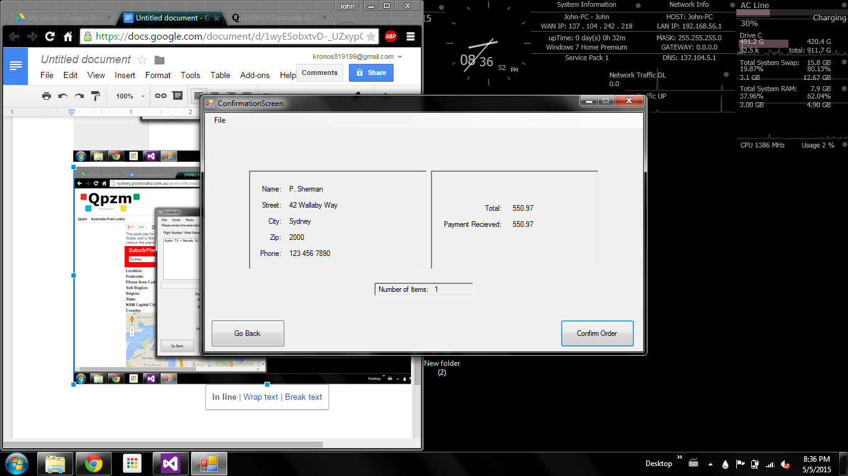

Cancel Reservation Screen

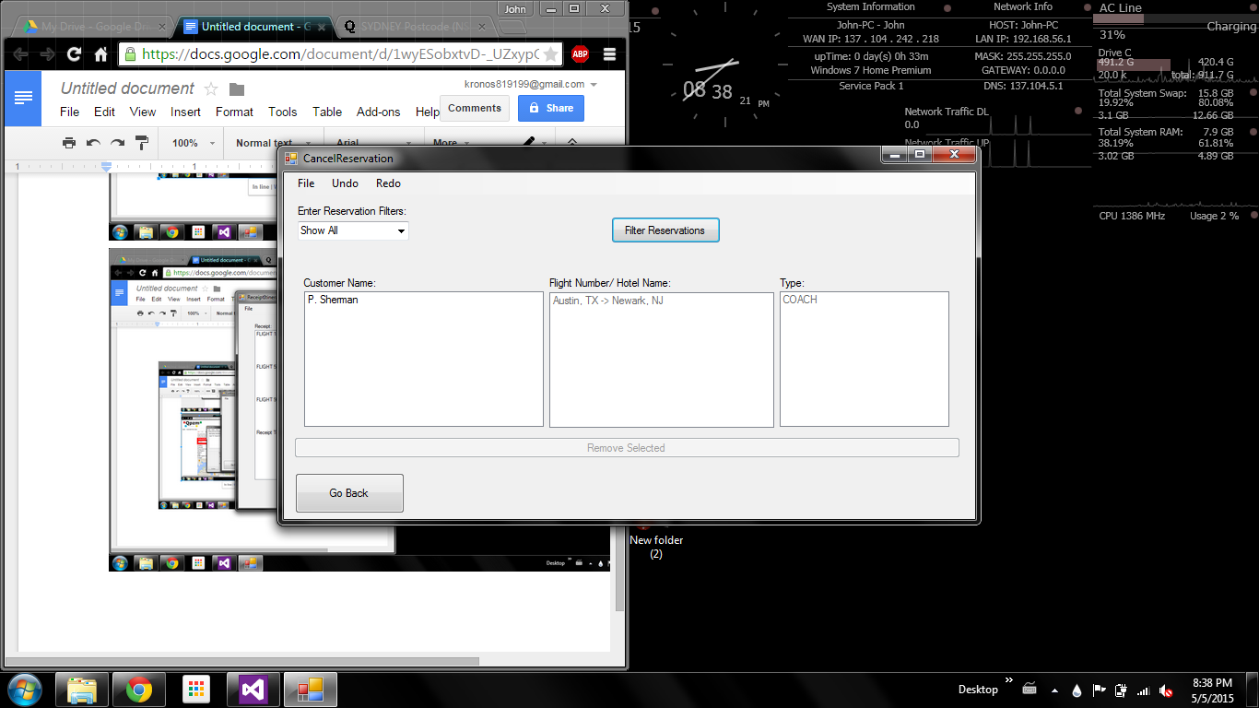

Receipt/Itinerary Screen

